Advanced Technologies Squad Artificial Intelligence Controller

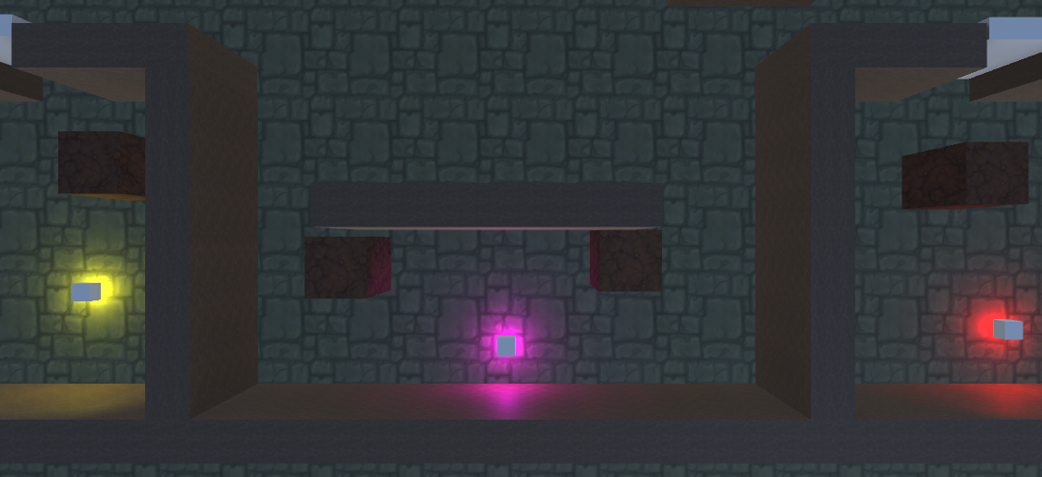

Abstract
Mitchell Height
Department of Computer Science and Creative Technologies
University of the West of England
Coldharbour Lane
Bristol, UK
m2-height@uwe.ac.uk
Updated 07/10/2014. In this sample document, we describe the formatting requirements for the Advanced Technologies reports (adapted from the Digital Media @ UWE Extended Abstracts), and this sample file offers recommendations on writing for the worldwide research readership. This template is based on the standard SIGCHI (Special Interest Group on Computer Human Interaction) ACM extended abstracts template

Author Keywords
Authors’ choice; of terms; separated; by semi-colons
Optional section to be included in your final version, but strongly encouraged.

Introduction to document
This format is to be used for submissions of reports for the Advanced Technologies module. We wish to give the a consistent, high-quality appearance and encourage students to experience writing for a wider research audience. We therefore ask that authors follow some simple guidelines. In essence, you should format your paper exactly like this document.
The easiest way to do this is simply to download a template from the module blackboard website and replace the example content as necessary.
All submissions of complete work using this template should be in.pdf format to preserve formatting and enable marking and feedback.

Introduction
Description of the task set/problem statement

Background Research
Document this as-you-go, or at least keep notes of research you are carrying out.

Outcomes
What your investigations have found and what you have developed from those investigations

Evaluation
Evaluate your outcomes and your approach, suggest further improvements or directions.

Text formatting
(Delete this section before submission!)
Please use an 8.5-point Verdana font, or other sans serifs font as close as possible in appearance to Verdana in which these guidelines have been set. (The “Normal” style for this document automatically gives you this font setting.) Arial 9-point font is a reasonable substitute for Verdana as it has a similar x-height. Please use serif or non-proportional fonts only for special purposes, such as distinguishing source code text.

Text styles
The template uses MS Word text styles to facilitate text formatting. The applicable text styles are:
- normal – for body text
- heading 1, heading 2, heading 3
- bullet list
- numbered list
- caption
- annotation – for notes in the narrow left margin
- reference – for bibliographic entries

Additionally, here is an example of footnoted text. (the footnote is created with the “footnote…” command under the “Insert” menu in MS Word). As stated in the footnote, footnotes should rarely be used.

Language, style, and content
The written and spoken language of SIGCHI is English. Spelling and punctuation may use any dialect of English (e.g., British, Canadian, US, etc.) provided this is done consistently. Hyphenation is optional. To ensure suitability for an international audience, please pay attention to the following:
- Write in a straightforward style. Use simple sentence structure. Try to avoid long sentences and complex sentence structures. Use semicolons carefully.
- Use common and basic vocabulary (e.g., use the word “unusual” rather than the word “arcane”).
- Briefly define or explain all technical terms. The terminology common to your practice/discipline may be different in other design practices/disciplines.
- Spell out all acronyms the first time they are used in your text. For example, “World Wide Web (WWW)”.
- Explain local references (e.g., not everyone knows all city names in a particular country).
Good Utilization of this Space Sample, as Side Bar
Preparation: Do not change the text box size or position.
Materials: This can not appear higher or lower on the page because of pagination and specific headers added during the indexing and pagination process.
Process: A 0.75 inch rule is beneficial to break this apart from the body text. The text in this text box should remain the same size as the Body Text: 8.5 Verdana or Arial (with use of bold and italics to highlight points)
Images & Figures: If you have any images in color, it is always good practice to print your paper out in black and white to ensure that the tones and screens used in your figures reproduce well in black and white, but your images will appear in full color in the electronic proceedings and in the ACM digital library. Images in your document should be at least 300 or 600 dpi for quality reproduction.
- Explain “insider” comments. Ensure that your whole audience understands any reference whose meaning you do not describe (e.g., do not assume that everyone has used a Macintosh or a particular application).
- Explain colloquial language and puns. Understanding phrases like “red herring” requires a cultural knowledge of English. Humor and irony are difficult to translate.
- Use unambiguous forms for culturally localized concepts, such as times, dates, currencies and numbers (e.g., “1-5-97” or “5/1/97” may mean 5 January or 1 May, and “seven o'clock” may mean 7:00 am or 19:00).
- Be careful with the use of gender-specific pronouns (he, she) and other gender-specific words (chairman, manpower, man-months). Use inclusive language (e.g., she or he, they, chair, staff, staff-hours, person-years) that is gender-neutral. If necessary, you may be able to use “he” and “she” in alternating sentences, so that the two genders occur equally often [6].

Figures

(Delete this section before submission!)
The examples on this and following pages should help you get a feel for how screen-shots and other figures should be placed in the template. Be sure to make images large enough so the important details are legible and clear.
Your document may use color figures, which are included in the page limit; the figures must be usable when printed in black and white.
If you aren’t familiar with Word’s handling of pictures, we offer one tip: the “format picture” dialog is the key to controlling position of pictures and the flow of text around them. You access these controls by selecting your picture, then choosing “Picture…” from the “Format” menu.
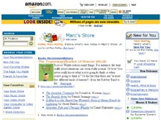
Figure 1. Insert a caption below each figure.
Column Head Samples | 1 | 2 | 3
Measurements result | 22.52 | 12.16 | 10.75
CogTool prediction | 22.72 | 12.26 | 10.60
CogTool error % | 0.009 | 0.008 | 0.014
Table 2. This sample table has the caption appearing below. Please use 0.75 rules/borders for your tables, align decimals or center text in the cells. For improved accessibility, header rows of tables should be marked. In Word, right click a header row, and select Table Properties | Row | Repeat as header at the top of each page.
As for the “picture” tab in that dialog, we recommend using Photoshop or other graphics software to scale images, rather than scaling them after you have placed them in Word. Word’s scaling tends to reduce the clarity and legibility of images more so than dedicated graphics software.
Figure 2: If your figure has a light background, you can set its outline to light gray, like this, to make a box around it. The column width is 8.5 cm (3.34”), so setting this picture to fill the column was easily done by right-clicking on it (option-click on the Mac), choosing “format picture,” then the “size” tab, and setting its width to 8.5 cm (3.34”).
Page five shows a treatment of large figures, too big to fit inside a single column of text.
All figures should include alt text for improved accessibility. In Word, right click the figure, and select Format Picture | Alt Text).

References and Citations

(Delete this section before submission)
You should be using the Harvard Referencing system as specified by the University Guidelines (see Library website for more information)
One good use of the narrow margin column: callouts that annotate a figure, either with text or a more detailed image.
Your references should be published materials accessible to the public. Internal technical reports may be cited only if they are easily accessible (i.e., you provide the address for obtaining the report within your citation) and may be obtained by any reader for a nominal fee. Proprietary information may not be cited. Private communications should be acknowledged in the main text, not referenced (e.g., “[Robertson, personal communication]”).

Accessibility

(Delete this section before submission)

The Executive Council of SIGCHI has committed to making SIGCHI conferences more inclusive for researchers, practitioners, and educators with disabilities. As a part of this goal, the all authors are asked to work on improving the accessibility of their submissions. Specifically, we encourage authors to carry out the following five steps:
- Add alternative text to all figures
- Mark table headings
- Generate a tagged PDF
- Verify the default language
- Set the tab order to “Use Document Structure”
For more information and links to instructions and resources, please see:
http://chi2014.acm.org/authors/guide-to-an-accessible-submission
So long as you don’t type outside the right margin, it’s okay to put annotations over here on the right, too. Remember to use the annotation text style.

Producing and testing PDF files

(Delete this section before submission)
We recommend that you produce a PDF version of your submission well before the final deadline. Your PDF file must be ACM DL Compliant. The requirements for an ACM Compliant PDF are available at:
http://www.sheridanprinting.com/typedept/ACM-distilling-settings.htm
Test your PDF file by viewing and/or printing it.

Acknowledgements
We thank all the volunteers, and all publications support and staff, who wrote and provided helpful comments on previous versions of this document. As well authors 1, 2, & 3 gratefully acknowledge the grant fron NSF (#1234-2012-ABC). Author 4 for example may want to acknowledge a supervisor/manager from their original employer. This whole paragraph is just for example … Some of the references cited in this paper are included for illustrative purposes only.

References format

(Delete this section before submission)
References must be the same font size as other body text.

References
 | Center column head | Center column head
child | 4.2 | 2.3 | 5.1 | 3.8
older adults | 2.8 | 2.2 | 3.1 | 4.7
Bob | 2.5 | 3.1 | 3.0 | 12.2
Dave | 0.75 rules | 2.5 | 3.2
Table 1. Sample narrow table in the left margin space.
Adobe Acrobat Reader 7. http://www.adobe.com/products/acrobat/.
Anderson, R.E. Social impacts of computing: Codes of professional ethics. Social Science Computing Review 10, 2 (1992), 453-469.
How to Classify Works Using ACM’s Computing Classification System.
http://www.acm.org/class/how_to_use.html.
Klemmer, R.S., Thomsen, M., Phelps-Goodman, E., Lee, R. and Landay, J.A. Where do web sites come from? Capturing and interacting with design history. In Proc. CHI 2002, ACM Press (2002), 1-8.
Mather, B.D. Making up titles for conference papers. Ext. Abstracts CHI 2000, ACM Press (2000), 1-2.
Schwartz, M. Guidelines for Bias-Free Writing. Indiana University Press, Bloomington, IN, USA, 1995.
Zellweger, P.T., Bouvin, N.O., Jehøj, H., and Mackinlay, J.D. Fluid Annotations in an Open World. Proc. Hypertext 2001, ACM Press (2001), 9-18.
The 1998 ACM Computing Classification System. http://www.acm.org/about/class/1998

Use footnotes sparingly, if at all.

